Basic Settings for Using Fldigi During NTX NVIS Nets by W5TTA
REVISED 2026-01-02
I’m not going to attempt to give complete instructions for making FlDigi talk to your rig, YouTube being the better resource for that, but I’ll mention the following highlights:
Under the Configure Menu: (always hit the “Save” button at the bottom of the window)
MiscOperator-Station: fill in your callsign & grid under station locator
IDsRsID:
Squelch open = 0
Only the following boxes should be checked:
“Mark prev freq/mode”,
“Disable freq change”
“Rx/Tx RsID EOT”
Rig Control
I highly recommend downloading and using FlRig here, but you may also find your rig
in the Hamlib dropdown or use some other mechanism.
SoundcardDevices
Choose your audio CODEC for the capture & playback.

Those are the essentials. Verify that your CAT control and PPT are working.

Now pull down the “Op Mode” menu and select “Contestia” then “Cont4-250”
Turn ON “RxID” in the upper right corner. This will ensure that if the net changes modes, you will change modes with us.
During nets, please turn OFF “TxID” in the upper right corner of FlDigi. The NCS station should be the only one controlling mode changes unless other stations are invited to do so when passing traffic.
The straw yellow area is the received pane, while the cyan blue is where you type what you intend to transmit. Check-ins will take the format
DE <CALLSIGN> <CALLSIGN> / <NAME> / <CITY OR TOWN> / <COUNTY> / <STATE>
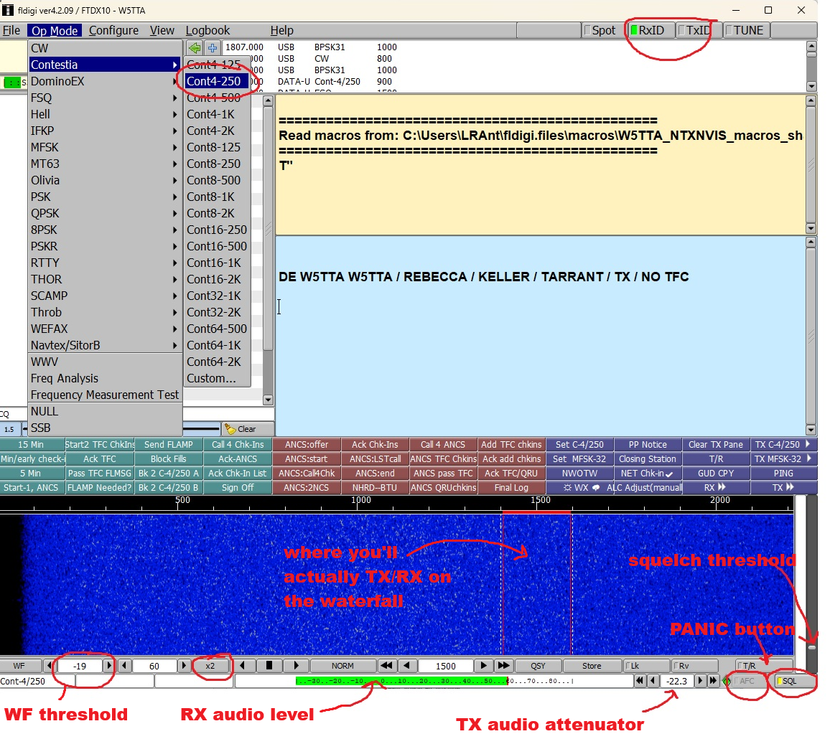It’s good practice to put a couple blank lines before and after the text you intend to transmit so that it’s less likely to be run together with noise and other transmissions when it’s received by other stations.
Unlike in VarAC, it’s up to you to wait till the frequency is clear when transmitting. The program will not sense for frequency busy.
The easiest way to send what you’ve got in the transmit pane is to hit the “T/R” macro button. This will transmit what you’ve got in the blue pane and then throw you back into receive. (Your macros will be fewer in number and look different from mine, but you’ll have one marked “T/R”.)
If you ever find yourself stuck in transmit, the T/R button at the bottom right, just above “AFC”, is your panic button that will cut transmission and put you back in receive.
One common pitfall to be aware of: as you transmit, you’ll see your outgoing transmission appear in red in the upper pane, as shown below. You can edit what you have in the transmit pane by moving your cursor to the desired position so long as the program hasn’t transmitted it yet. Often this feels like a race—can you complete the desired edit before the transmitter reaches the cursor? In Contestia 4/250 you usually can. Faster modes, perhaps not! Anyway, the pitfall is, if you forget to move the cursor to the bottom of the pane when you’re done editing and just leave it in the middle of the text you edited, you’ll find yourself stuck in transmit.
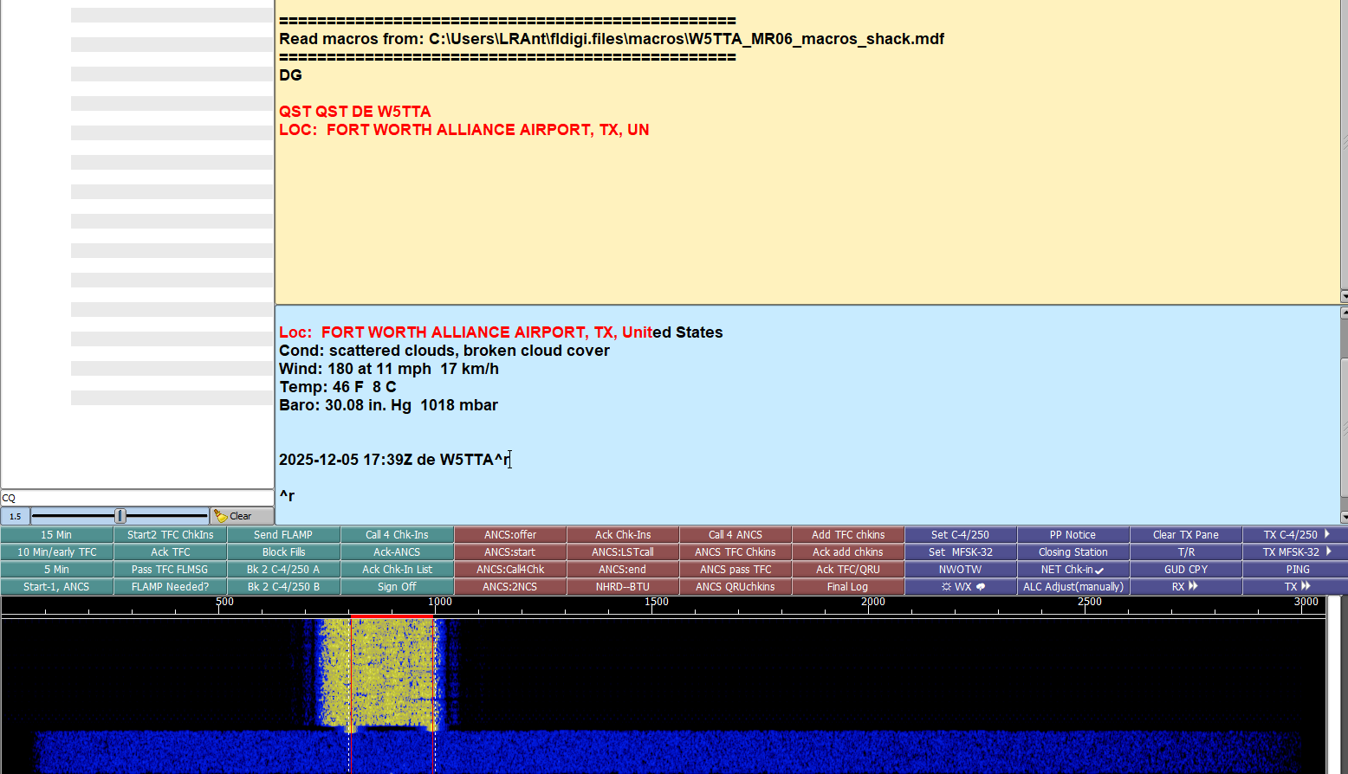
You want the squelch in the lower right corner to be ON (green rectangle, or perhaps yellow). The squelch level is controlled by the slider just above the button. Set it to be just above the noise floor (I find about 20% of the way up from the bottom is a good starting point.)
Your AFC setting, bottom right corner just to the left of the squelch, should be OFF (text grayed out). AFC stands for automatic frequency control—it makes the program attempt to adjust your waterfall position to match the incoming signal. Sounds like a good idea but it isn’t; stray signals will pull you away from where you want to be.
You want your received signal level (the horizontal green bar at the middle bottom) to read around 2/3 scale. You’ll control this through your PC sound settings (recording level incoming from the rig), just as you would for other digital programs. I usually leave RF gain on max on the rig.
The vertical red bars on the waterfall represent the precise location where you’ll be transmitting--just like in WSJT-X, and the width of the transmission, which of course depends on the mode. Contestia 4/250 occupies 250 Hz (and uses 4 tones.)
You’ll need to adjust your transmit audio level so as not to trigger ALC. Find a clear frequency, then watch your ALC meter while hitting the TUNE button. You can adjust your output through a combination of the sound card settings (playback level outgoing to the rig) and the TX attenuator setting in Fldigi. The latter is just to the left of the “AFC” diamond at the bottom right.
The first number field to the right of the “WF” button in the lower left is the threshold signal level shown on the waterfall. If your waterfall is all yellow, your threshold is too low and you need to make it less negative with the arrow buttons.
The next field on the bottom right is the signal range. The default of 60dB is usually fine.
Change the next button to “x2” to show more of your 3k passband on the waterfall.
The center field is your place on the waterfall—where you are above the dial frequency on the rig. For our net, we’ll be at 1500 for best reception in the center of the passband.

Troubleshooting tips from Karlan AI5TS:
*If you see on waterfall, but no copy, turn off squelch in bottom right hand corner
*If you don't see anything in waterfall, set the value almost bottom left to -30 (next to arrows)
*ctrl+t starts transmit, end your message with ^r and that will signal to stop Tx
*if you move your cursor into middle of message during TX it'll pause indefinitely stuck in Tx

